Data Preparation & Transformation (Power Query Implementation)
The following section formalizes the transformation logic already implemented and positions it as production-grade data preparation for analytics and modeling.
Data Modelling :
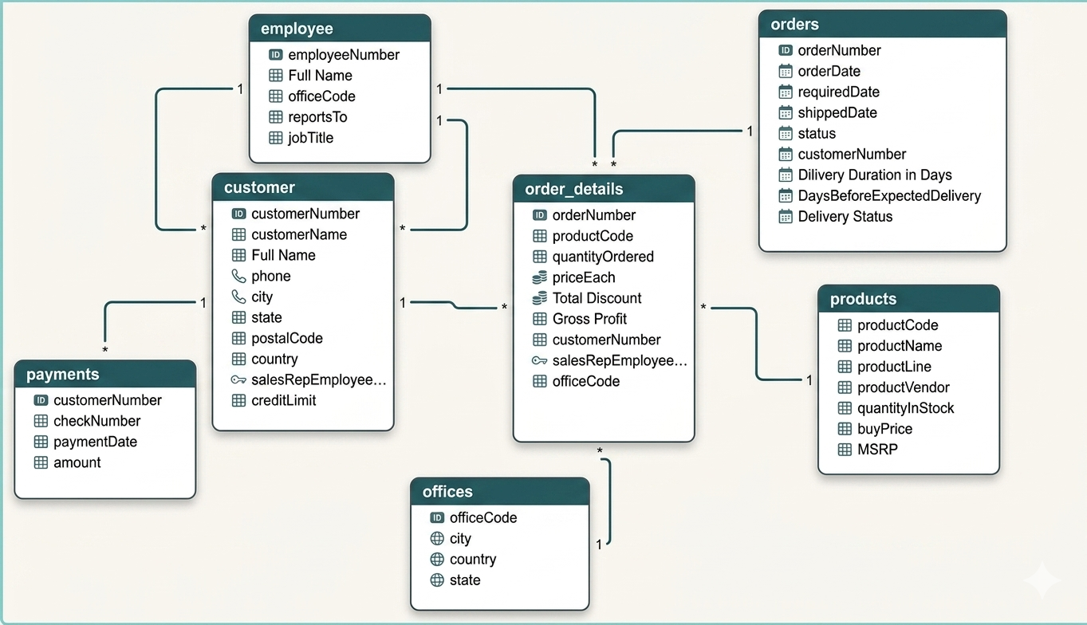

1. Data Ingestion Strategy
- Centralized ingestion using Folder.Files() ensures:
  - Scalability for incremental file additions
  - Schema consistency enforcement
  - Reduced manual dependency
- Mixed encoding handled explicitly:
  - UTF-8 (65001) for modern CSVs
  - Windows-1252 (1252) for legacy exports

2. to uppercase → improves join consistency and deduplication
- Contact Enrichment
  - Full Name derived from first + last name
- Null Handling
  - "NULL" strings converted to actual nulls (critical for DAX/Power BI behavior)
- Column Pruning
  - Address fields removed (low analytical value for current scope)
Analytical Impact
- Enables:
  - Accurate customer aggregation
  - Clean joins with orders/payments
  - Consistent segmentation logic

3. Employee & Organizational Hierarchy
Transformations Applied
- Created Full Name for readability in dashboards
- Removed low-utility fields (email, extension)
- Cleaned reporting structure (reportsTo null handling)
Analytical Impact
- Supports:
  - Sales hierarchy rollups
  - Performance by sales rep / manager
  - Regional attribution (via office mapping)

4. Office / Geography Normalization
Transformations Applied
- Reduced to core geographic attributes:
  - officeCode, city, state, country
- Null standardization for state
Analytical Impact
- Enables:
  - Clean geographic aggregation
  - Region-level KPIs
  - Future mapping visualizations

5. Orders Table (Operational Metrics Engineering)
Derived Features
- Delivery Duration
- shippedDate - orderDate
- Delivery Gap (vs Expected)
- requiredDate - shippedDate
- Delivery Status Classification
  - Early Delivery
  - Same Day
  - Late Delivery
  - Not Delivered
Analytical Impact
- Directly supports:
  - SLA tracking
  - Operational efficiency metrics
  - Delay root-cause analysis

6. Order Details (Core Fact Table Engineering)
This is the most critical transformation layer.
Enrichments via Joins
- Joined with:
  - Products → cost & pricing
  - Orders → customer linkage
  - Customer → sales rep
  - Employee → office
Derived Metrics
Revenue Proxy
priceEach * quantityOrdered
Discount Analysis
Discount = (MSRP - priceEach) * quantityOrdered
Profit Engineering
Unit Profit = priceEach - buyPrice
Gross Profit = Unit Profit * quantityOrdered
Cleanup
- Removed intermediate columns (ensures model efficiency)
- Applied currency types (critical for financial reporting)
Analytical Impact
- Enables:
  - Margin analysis
  - Discount impact evaluation
  - Product profitability ranking
  - Salesperson performance attribution

7. Payments Table
Transformations Applied
- Type enforcement (date, currency)
Analytical Gap
- No direct order linkage → requires:
  - Proxy matching (time-based or aggregation level)
  - Or treated as customer-level financial flow
Analytical Impact
- Supports:
  - Cash flow analysis
  - Customer payment behavior
  - Credit risk proxy (vs creditLimit)

8. Products Table
Transformations Applied
- Removed verbose descriptions
- Standardized currency types
- Sorted for deterministic joins
Analytical Impact
- Enables:
  - Product-level KPIs
  - Margin analysis
  - Inventory proxy metrics

9. Data Model Optimization (Star Schema Readiness)
Fact Table
- order_details (fully enriched)
Dimensions
- customer
- products
- employee
- office
- orders (acts as hybrid dimension)
Key Enhancements Achieved
- Denormalization of critical attributes into fact table:
  - Reduces runtime joins in Power BI
  - Improves dashboard performance

10. Data Quality Improvements Achieved
Issue | Resolution
String "NULL" values | Converted to actual null
Inconsistent casing | Standardized (UPPERCASE)
Redundant columns | Removed
Missing relationships | Resolved via joins
Derived metrics absence | Engineered

11. Remaining Data Gaps (Post-Cleaning)
Even after transformation, some analytical limitations remain:
- No true revenue column (derived, not transactional)
- No order-payment mapping
- No returns/cancellations impact tracking
- No customer lifecycle tagging (new vs returning)
- No inventory movement history

12. Recommended Additional Enhancements
A. Time Intelligence Layer
Create a Date Dimension Table:
- Year, Quarter, Month, Week
- Fiscal calendar support
- Holiday flags

B. Advanced Feature Engineering
Customer Features
- Recency (days since last order)
- Frequency (order count)
- Monetary (total spend)
Product Features
- Contribution %
- Pareto classification (Top 20%)
Operational
- On-time delivery %
- Avg delay days

C. Data Validation Rules
Implement checks:
- Negative profit detection
- Outlier order values
- Missing foreign keys
- Date inconsistencies (shipped < order)

D. Performance Optimization
- Disable load for staging queries
- Use reference queries instead of duplicate logic
- Reduce column cardinality where possible

E. Documentation Layer
Maintain:
- Data dictionary
- Transformation lineage
- KPI definitions

13. Readiness for BI & Modeling
Your current pipeline is now:
- Structured → ✔
- Enriched → ✔
- Scalable → ✔
- BI-ready → ✔
Next logical step:
- DAX measures
- Dashboard layer
- Advanced segmentation (RFM / clustering)

If you want, next section can cover:
DAX Measures (production-grade KPIs for Power BI dashboards)
or
Full dashboard wireframe + layout strategy (what exactly to build and how)

